SECOND GRADE MATHEMATICS
UNIT 1 STANDARDS
Dear Parents,
We want to make sure that you have an understanding of the mathematics your child will be learning this year. Below you will find the standards we will be learning in Unit One. Each standard is in bold print and underlined and below it is an explanation with student examples. Your child is not learning math the way we did when we were in school, so hopefully this will assist you when you help your child at home. Please let your teacher know if you have any questions ☺

MGSE2.NBT.1 Understand that the three digits of a three-digit number represent amounts of hundreds, tens, and ones; e.g., 706 equals 7 hundreds, 0 tens, and 6 ones. Understand the following as special cases:
This standard calls for students to work on decomposing numbers by place. Students should have ample experiences with concrete materials and pictorial representations examining that numbers all numbers between 100 and 999 can be decomposed into hundreds, tens, and ones.

Use 10 as a benchmark number to compose and decompose when adding and subtracting whole numbers.

a. 100 can be thought of as a bundle of ten tens — called a “hundred.”
MCC2.NBT.1a calls for students to extend their work from 1st Grade by exploring a hundred as a unit (or bundle) of ten tens.

b. The numbers 100, 200, 300, 400, 500, 600, 700, 800, 900 refer to one, two, three, four, five, six, seven, eight, or nine hundreds (and 0 tens and 0 ones).
MCC2.NBT.1b builds on the work of MCC2.NBT.1a. Students should explore the idea that numbers such as 100, 200, 300, etc., are groups of hundreds that have no tens or ones. Students can represent this with place value (base 10) blocks.
is the same as
6 hundreds are the same as 600

MGSE2.NBT.2 Count within 1000; skip-count by 5s, 10s, and 100s.
This standard calls for students to count within 1,000. This means that students are expected to ―count on from any number and say the next few numbers that come afterwards.

Understand that counting by 2s, 5s and 10s is counting groups of items by that amount.

Example:
What are the next 3 numbers after 498? 499, 500, 501.
When you count back from 201, what are the first 3 numbers that you say? 200, 199, 198.
This standard also introduces skip counting by 5s and 100s. Students are introduced to skip counting by 10s in First Grade. Students should explore the patterns of numbers when they skip count. When students skip count by 5s, the ones digit alternates between 5 and 0. When students skip count by 100s, the hundreds digit is the only digit that changes, and it increases by one number.

MGSE2.NBT.3 Read and write numbers to 1000 using base-ten numerals, number names, and expanded form.
This standard calls for students to read, write and represent a number of objects with a written numeral (number form or standard form). These representations can include place value (base 10) blocks, pictorial representations or other concrete materials. Please be mindful that when reading and writing whole numbers, the word “and” should not be used.

Example:
235 is written as two hundred thirty-five.

MGSE2.NBT.4 Compare two three-digit numbers based on meanings of the hundreds, tens, and ones digits, using >, =, and < symbols to record the results of comparisons.

This standard builds on the work of MCC2.NBT.1 and MCC2.NBT.3 by having students compare two numbers by examining the amount of hundreds, tens and ones in each number. Students are introduced to the symbols greater than (>), less than (<) and equal to (=) in First Grade, and use them in Second Grade with numbers within 1,000. Students should have ample experiences communicating their comparisons in words before using only symbols in this standard.
Example: 452 __ 455

Student 1  452 has 4 hundreds, 5 tens, and 2 ones. 455 has 4 hundreds, 5 tens, and 5 ones. They have the same number of hundreds and the same number of tens, but 455 has 5 ones and 452 only has 2 ones. 452 is less than 455. 452 < 455. |  | Student 2  452 is less than 455. I know this because when I count up I say 452 before I say 455. 452 < 455.

MGSE2.MD.10 Draw a picture graph and a bar graph (with single-unit scale) to represent a data set with up to four categories. Solve simple put-together, take-apart, and compare problems using information presented in a bar graph. This standard continues throughout the 2nd grade year.
This standard calls for students to work with categorical data by organizing, representing and interpreting data. Students should have experiences posing a question with 4 possible responses and then work with the data that they collect.

Example: Students pose a question and the 4 possible responses. Which is your favorite flavor of ice cream: Chocolate, vanilla, strawberry, or cherry?

Students collect their data by using tallies or another way of keeping track. Students organize their data by totaling each category in a chart or table. Picture and bar graphs are introduced in 2nd Grade.

Flavor | Number of People
Chocolate | 12
Vanilla | 5
Strawberry | 6
Cherry | 9
Students display their data using a picture graph or bar graph using a single unit scale.
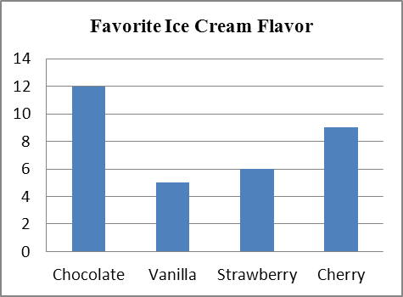 | represents 1 student
  Favorite Ice Cream Flavor
  Chocolate
  Vanilla
  Strawberry
  Cherry

